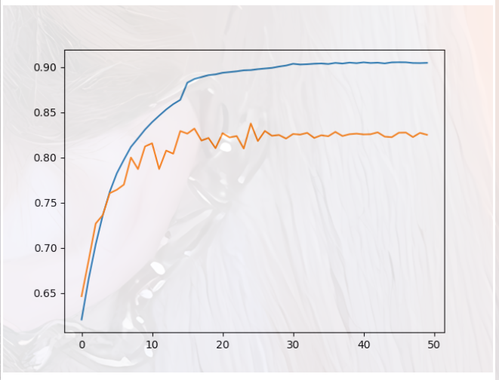

cvit_deepfake_detection_dfdc_ff

0.9055897052909748 0.8377704972193161

prediction Acc: 77.82805429864254%

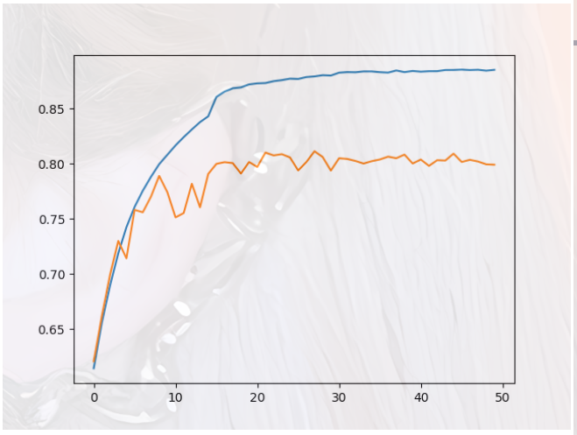

cvit_deepfake_detection_dfdc_ff_masked

0.8855518638729379 0.8114820903150943

prediction Acc: 79.18552036199095%

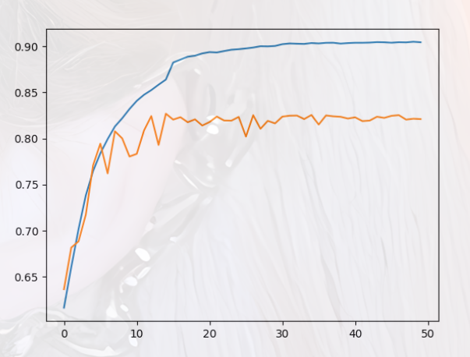

cvit_deepfake_detection_dfdc_ff原

0.9049386262231668 0.8269093111612796

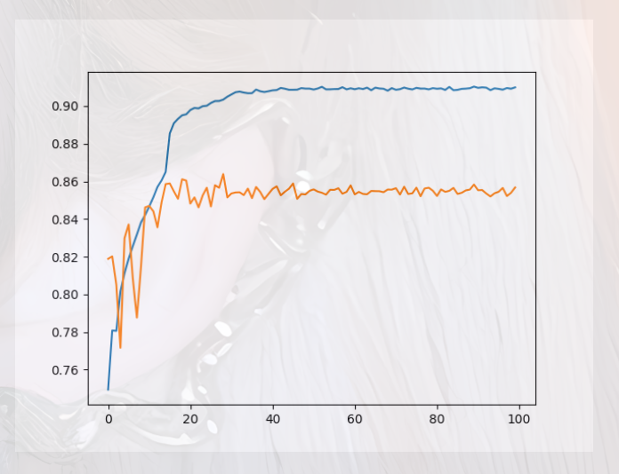

cvit_deepfake_detection_v1

0.9103302223120883 0.8638942050725013

prediction Acc: 90.49773755656109%

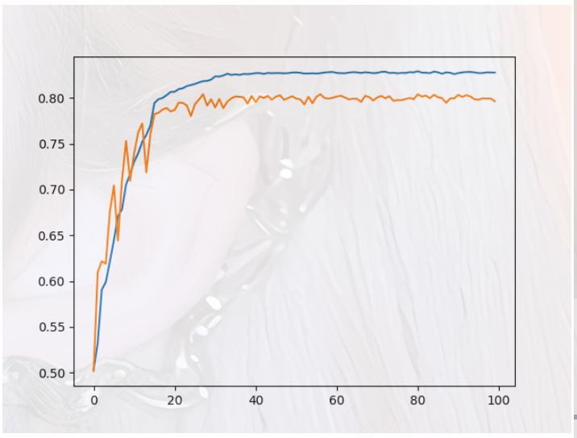

cvit_deepfake_detection_掩码数据

0.829051688358679 0.8039448956016483

prediction Acc: 79.63800904977376%

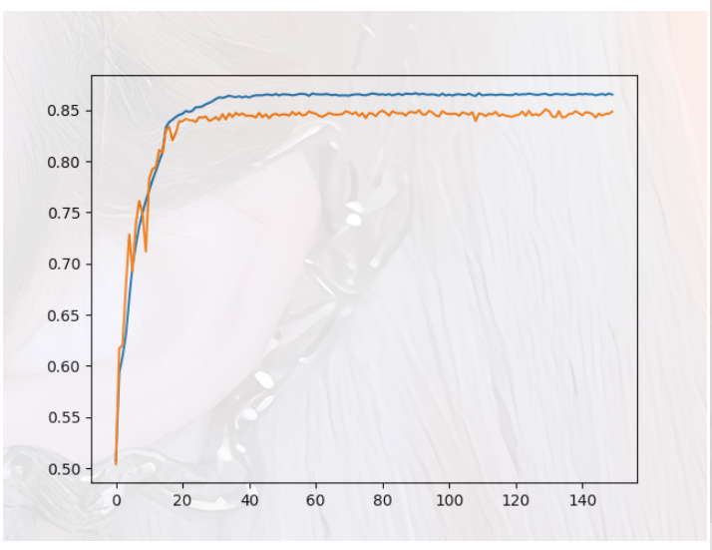

cvit_deepfake_detection_无预训练

0.866713673763678 0.850905346262765

prediction Acc: 85.52036199095022%

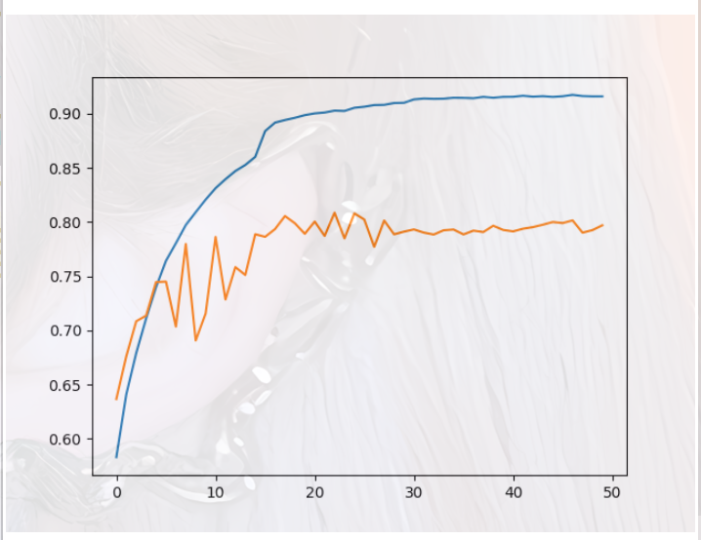

res18vit_deepfake_detection_souce_data

0.917311688862499 0.8085814811636489

prediction Acc: 81.44796380090497%

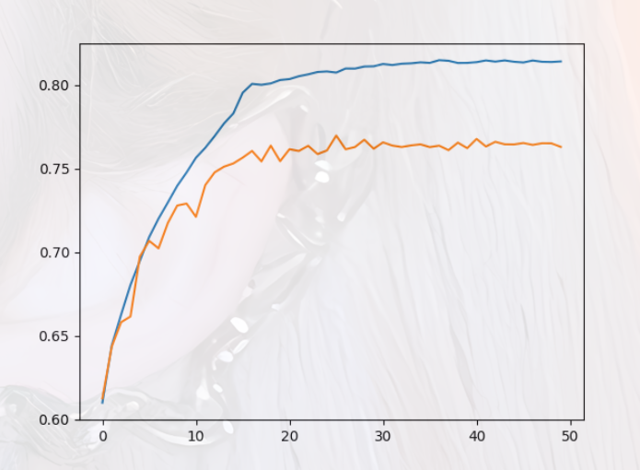

res18vit_deepfake_detection_dfdc_ff

0.8148829015147162 0.7697676339408623

prediction Acc: 81.44796380090497%

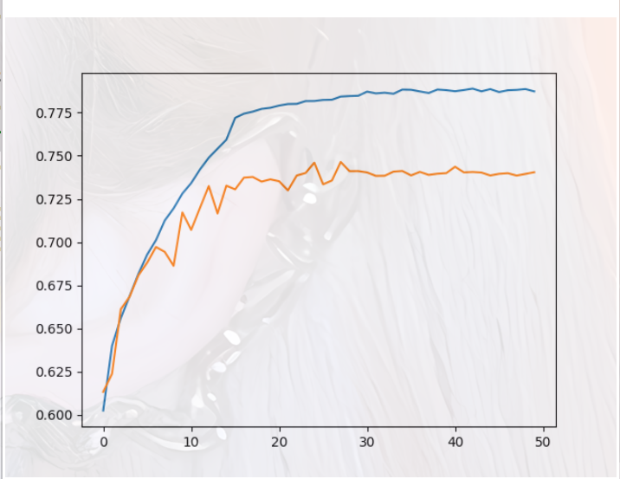

res18vit_deepfake_detection_dfdc_ff_masked

0.7888993450997716 0.7463911259686977

prediction Acc: 71.04072398190046%

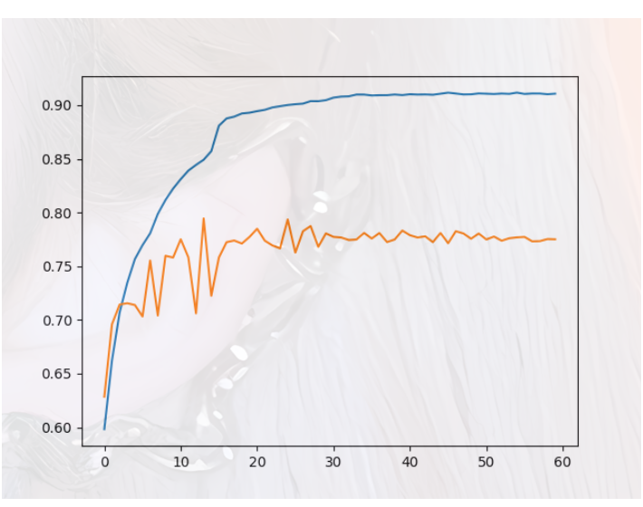

res34cvit_deepfake_detection_v1

0.9116977236689476 0.7945230213662353

prediction Acc: 75.1131221719457%

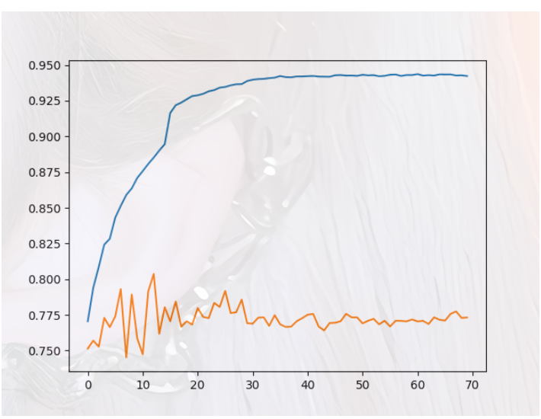

res50cvit_deepfake_detection_v1

0.9435865782668383 0.8037315678603671

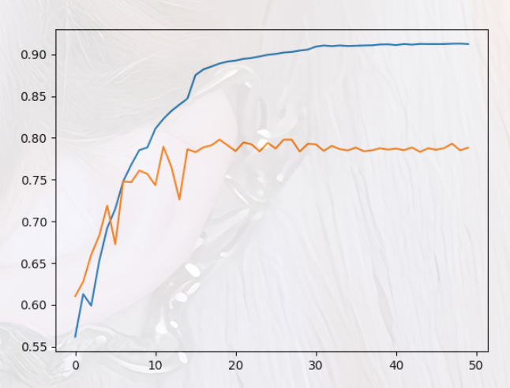

res101cvit_deepfake_detection_v1

0.9128583849351091 0.7980200989950502

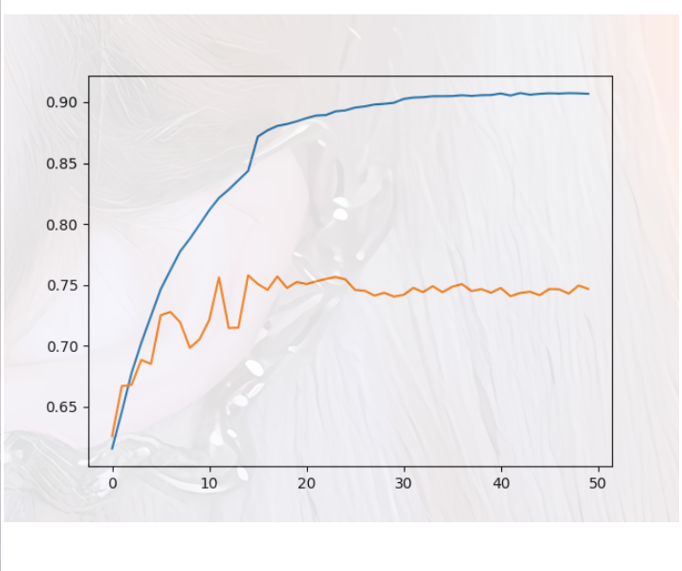

res101cvit_deepfake_detection_v2

0.9074409101067396 0.7578393018356907

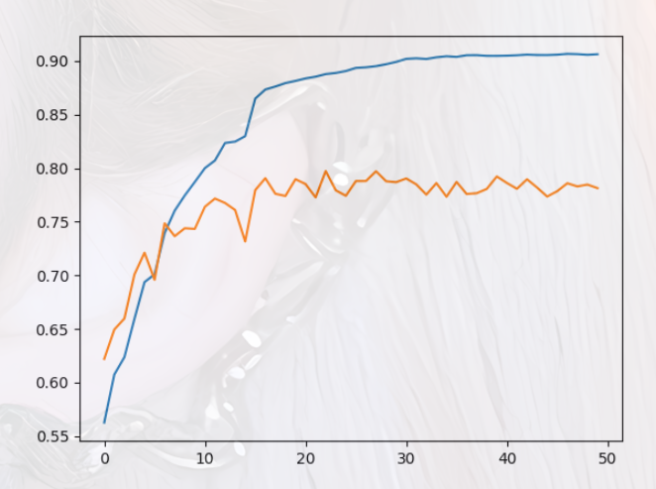

res101cvit_deepfake_detection_v3

0.9066555687505302 0.797288251952287

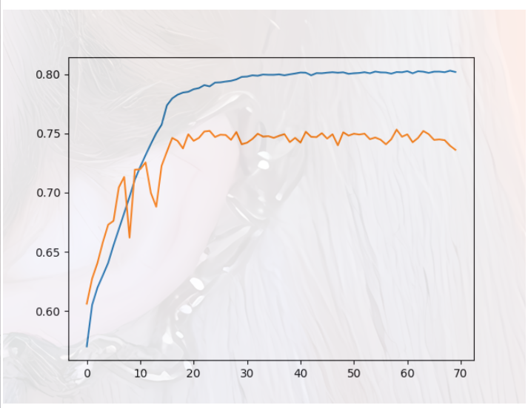

KanRes34_deepfake_v1

0.8029254951206274 0.7531681580716909

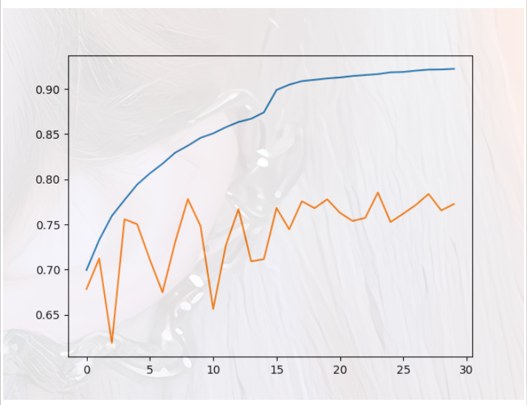

KanRes34_deepfake_v2

0.922419572828759 0.7853238848945671

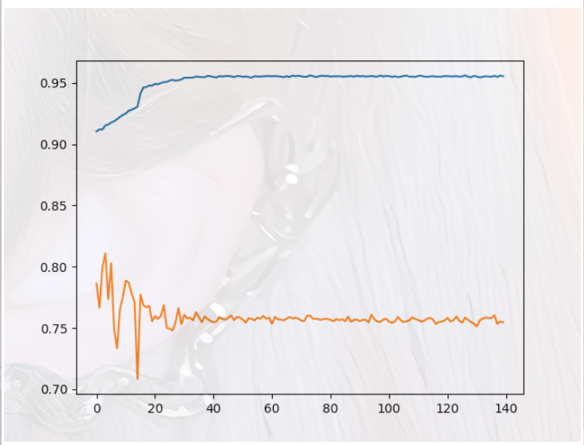

KanRes34_deepfake_v3

0.9562399565805016 0.8109622579699649

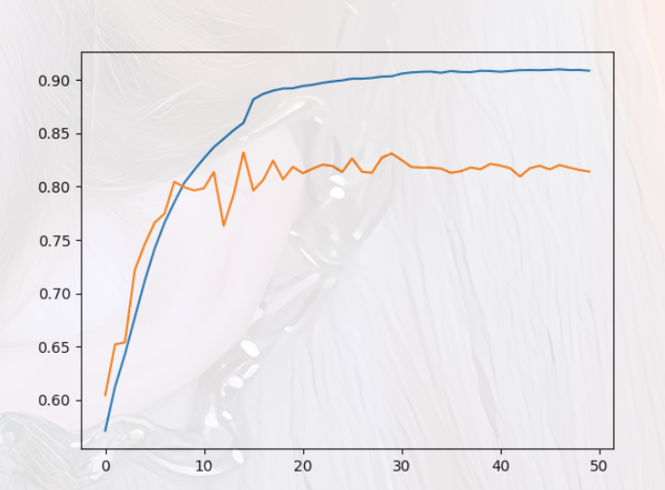

cvitBFM尾部_deepfake_detection_souce_data

0.910122783951141 0.8321462284390286

prediction Acc: 84.16289592760181%

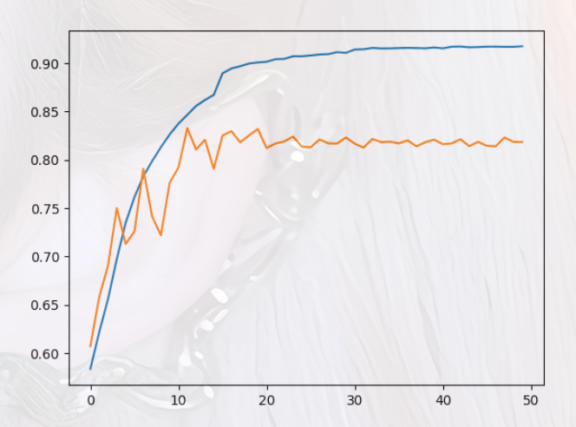

cvitBFM头部_deepfake_detection_souce_data

0.9175237509542795 0.8329013987814297

prediction Acc: 85.06787330316742%

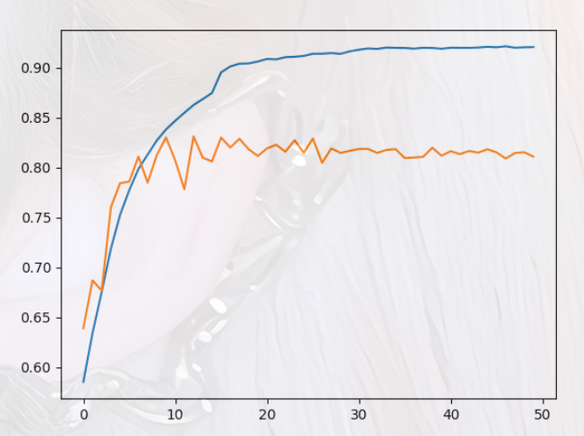

cvitGCSA头部_deepfake_detection_souce_data

0.921600644668759 0.8313567321719729

prediction Acc: 76.47058823529412%

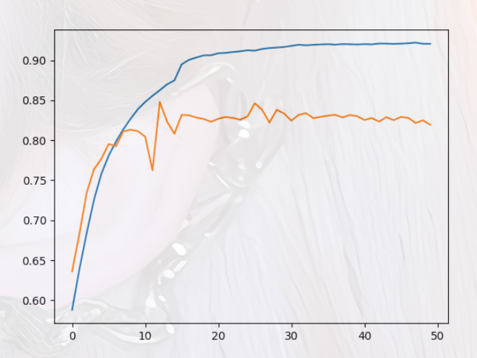

cvitGGCA头部_deepfake_detection_souce_data

0.9219611502247859 0.8478846648931606

prediction Acc: 87.78280542986425%

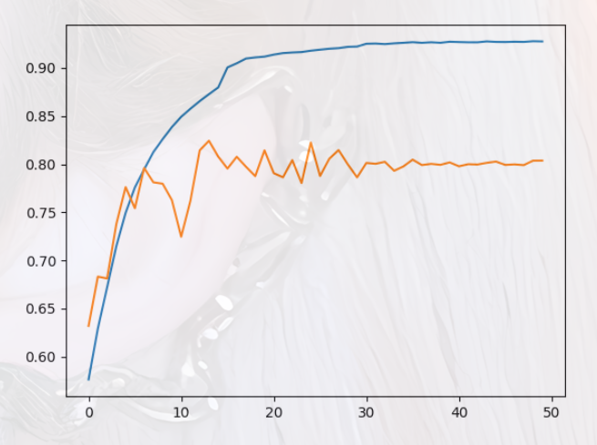

cvitMDFA头部_deepfake_detection_souce_data

0.9277398422258037 0.8243199176177809

prediction Acc: 81.44796380090497%

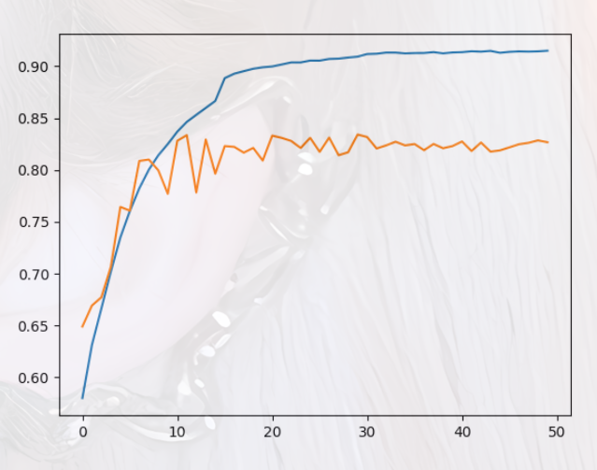

cvitMDFA尾部_deepfake_detection_souce_data

0.9149577996437357 0.8341371320689951

prediction Acc: 82.80542986425338%

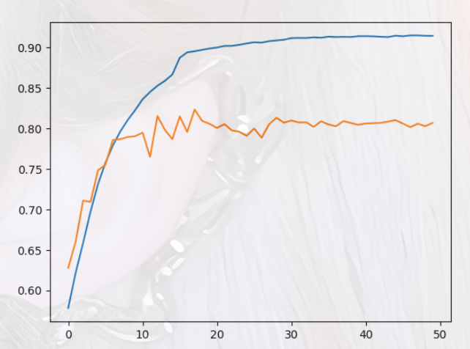

cvitMECS头部_deepfake_detection_souce_data

0.9150532275850369 0.8234102806144341

prediction Acc: 83.710407239819%

deepfake_cvit_gpu_inference_ep_50.csv

prediction Acc: 84.16289592760181%

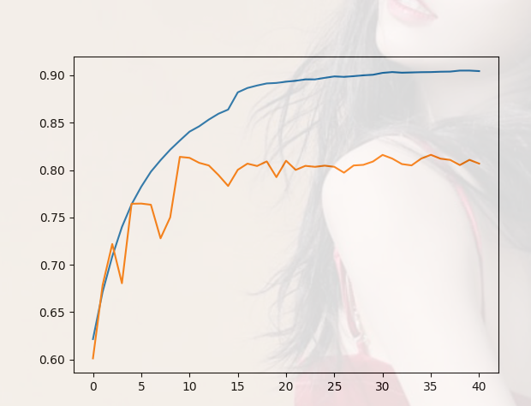

cvitGGCA1

0.9049501158537752 ，0.8160618908650404

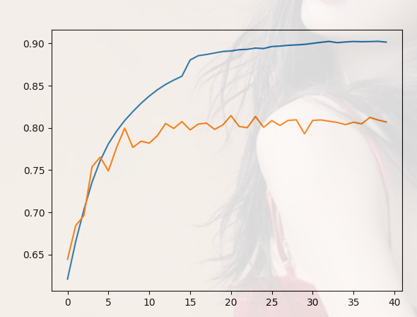

CvitGGCA2

0.9025909117021886, 0.8145614228291393

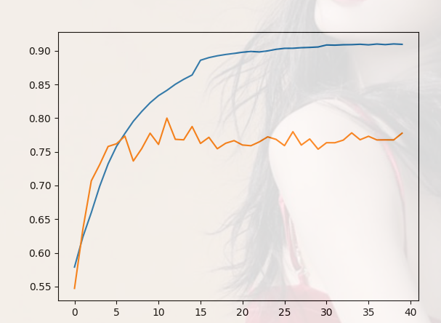

cvitGGCA3

0.9100697684281959 0.7999828370376727

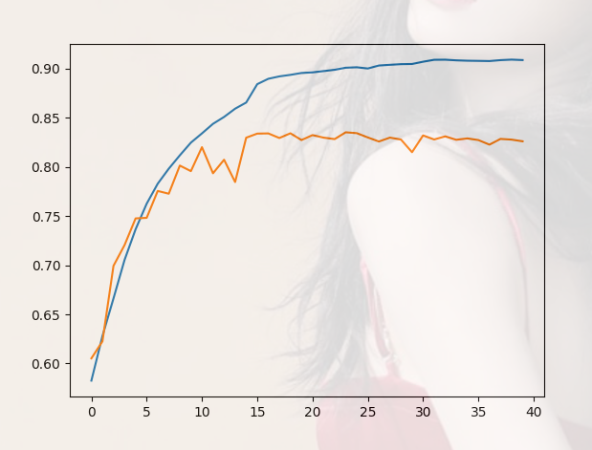

CvitGGCA4

0.909316948002375 0.835338539431906

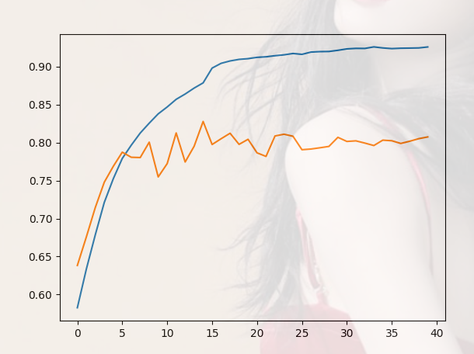

cvit_GGCA4_MDFA5

0.9256404275171771 0.8275980434222947

Prediction: 83.257918552036

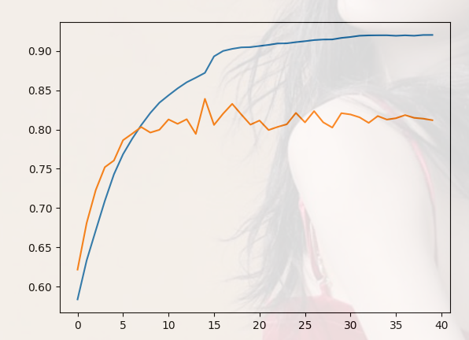

cvit_GGCA5_BFM4

0.9205827466282128 0.839200205955548

Prediction: 81.90045248868778

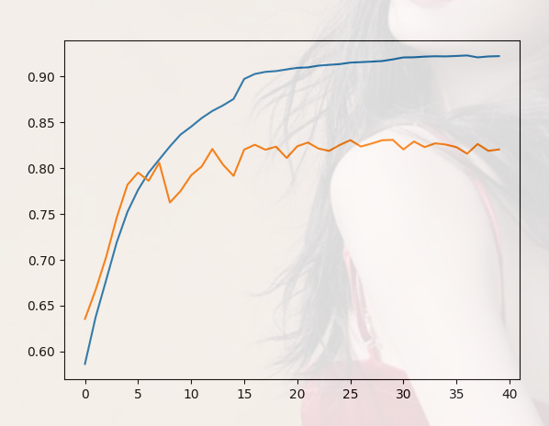

cvit_GGCA5_BFM4_LOSS

0.9231380948341675 0.8309963099630997

Prediction: 81.90045248868778

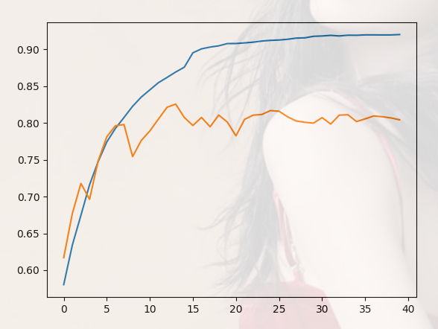

cvit_GGCA5_MDFA4

0.920153320892357 0.8256757916416374

Prediction: 80.99547511312217%

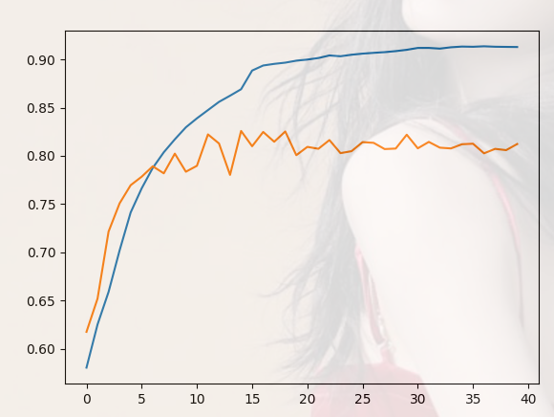

cvit_GGCA4_BFM5

0.9135528882856901 0.8258130953402557

84.16289592760181%



CVIT_BFM_MDFA

0.9256775383832386 0.8310992877370634

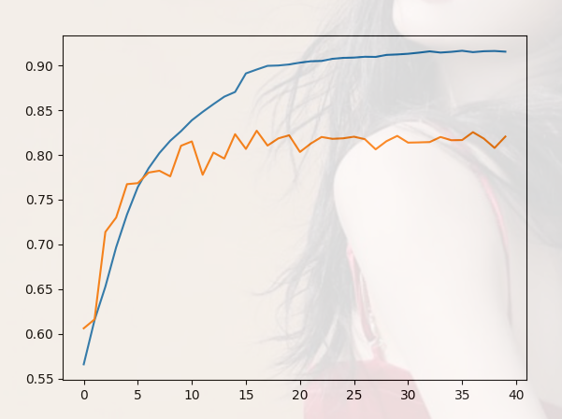

cvit_MDFA_GGCA_BFM——本机

0.9165853761981508 0.8271346434394576

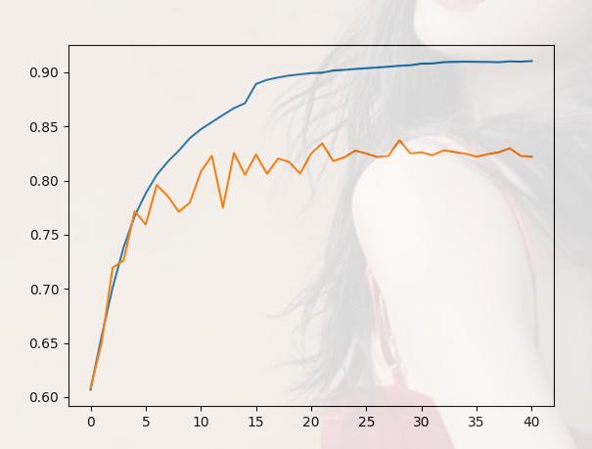

cvit_MDFA_GGCA_BFM——3090

0.9103272629784952 0.8371785694620341

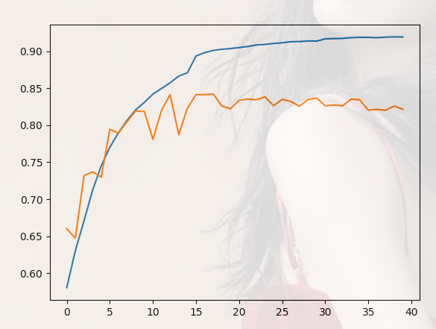

cvit_BFM_GGCA_MDFA --4090

0.9197238951565019 0.8423925169484253

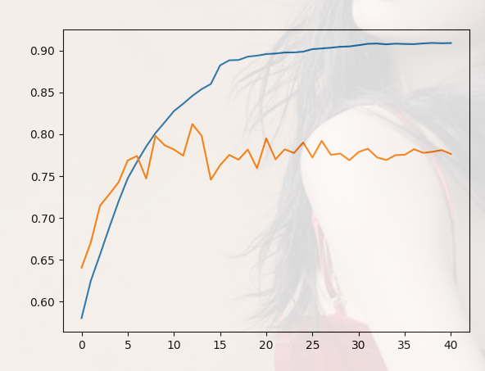

cvit_GGCA_BFM_MDFA—4090

0.909210916956484 0.812220029177036

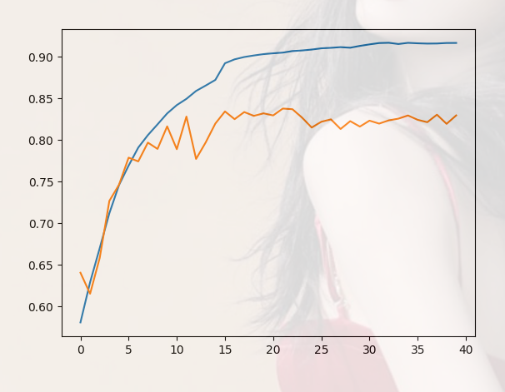

cvit_GGCA_BFM_MDFA—本机

0.916627788616507 0.8376898652707457

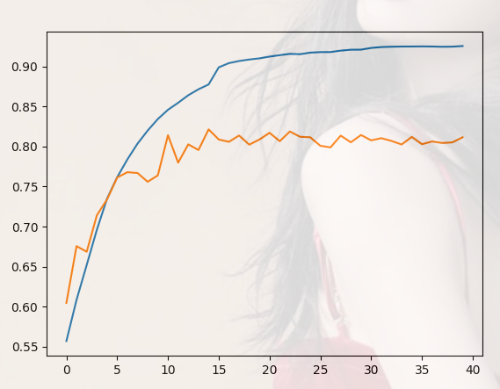

cvit_GGCA_MDFA_BFM—4090

0.9254972856052253 0.821385051059813

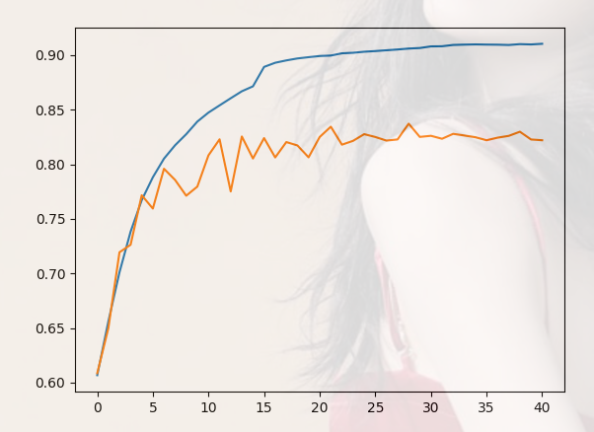

cvit_MDFA_GGCA_BFM—4090

0.9103272629784952 0.8371785694620341